CAPSTONE PROJECT DOCUMENTATION
PROJECT 1—THREAT MODEL:
1)Threat Dragon DFD
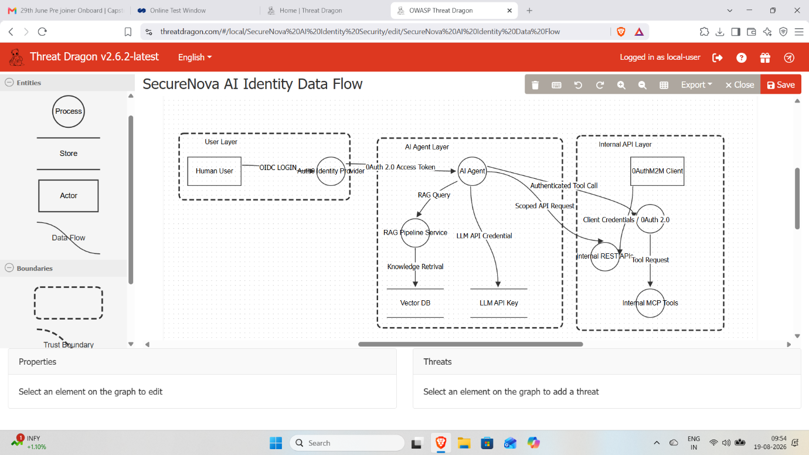
OWASP Threat Dragon data-flow diagram showing the Human User, Auth0, AI Agent, RAG Pipeline, Internal REST API, MCP Server, and trust boundaries.
2)Threat Analysis
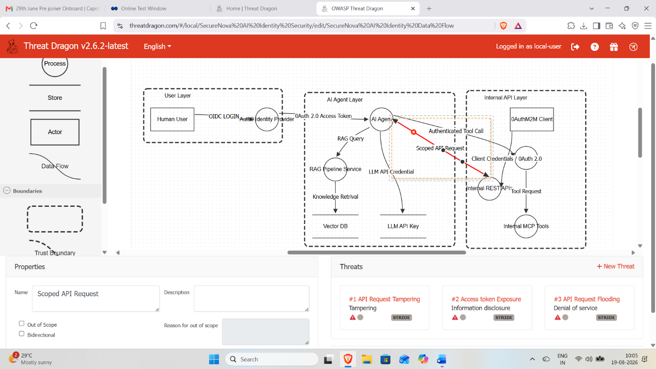
Threat Dragon threat panel showing three STRIDE threats: API Request Tampering, Access Token Exposure, and API Request Flooding.
3)LLM API Key EXfiltration AttackTree
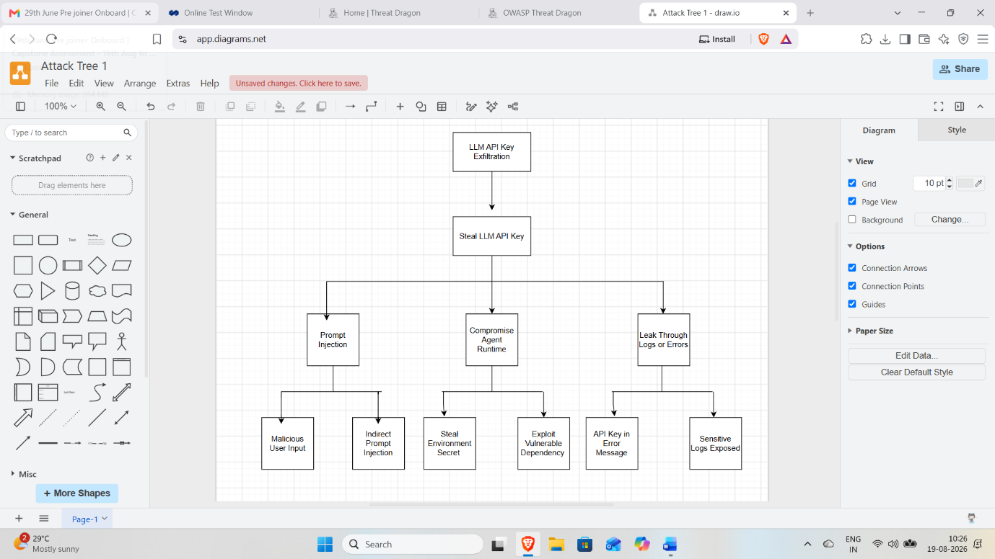
Attack Tree 1 showing the attack paths for LLM API Key Exfiltration through prompt injection, agent runtime compromise, and logs or errors.

4)Agent Identity Spoofing
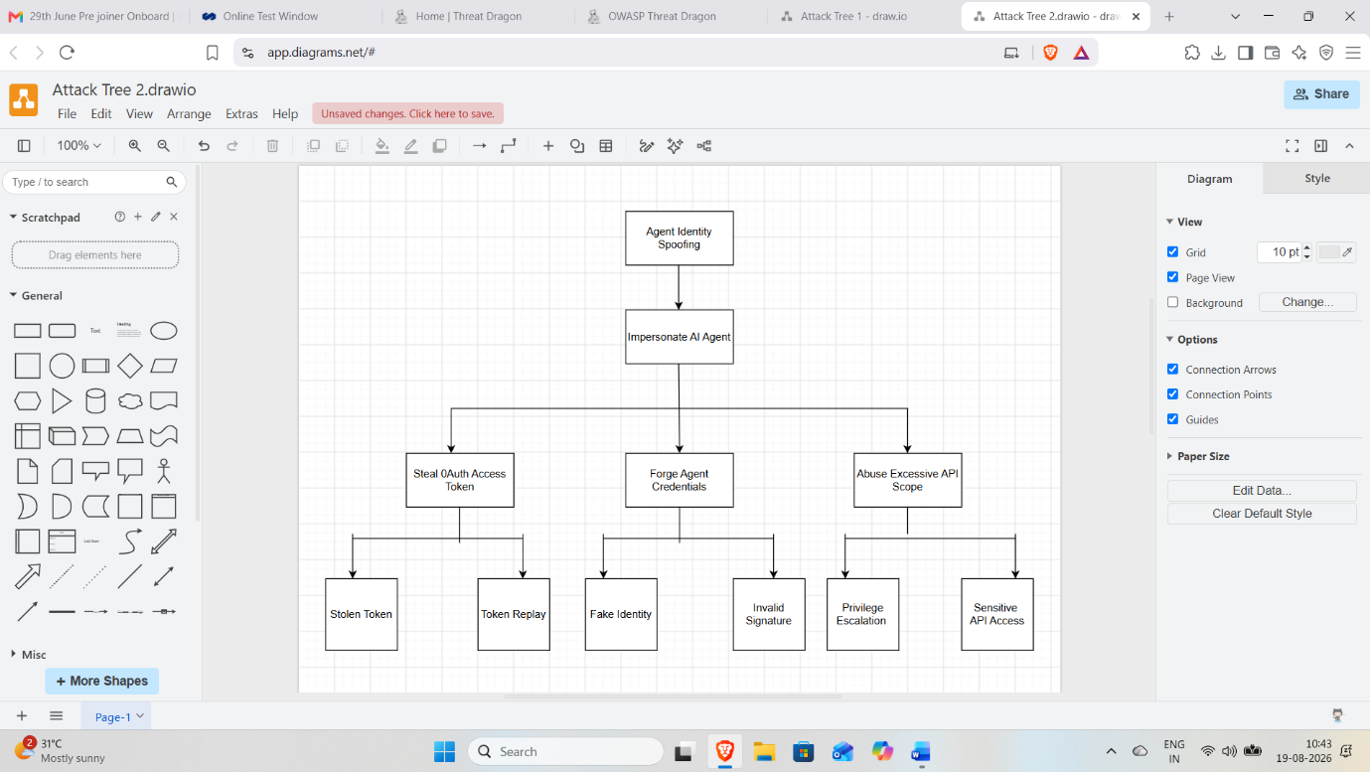
Attack Tree 2 showing the attack paths for Agent Identity Spoofing, including stolen tokens, forged credentials, and excessive API scope.

5)RAG Chunk poisoning Attack
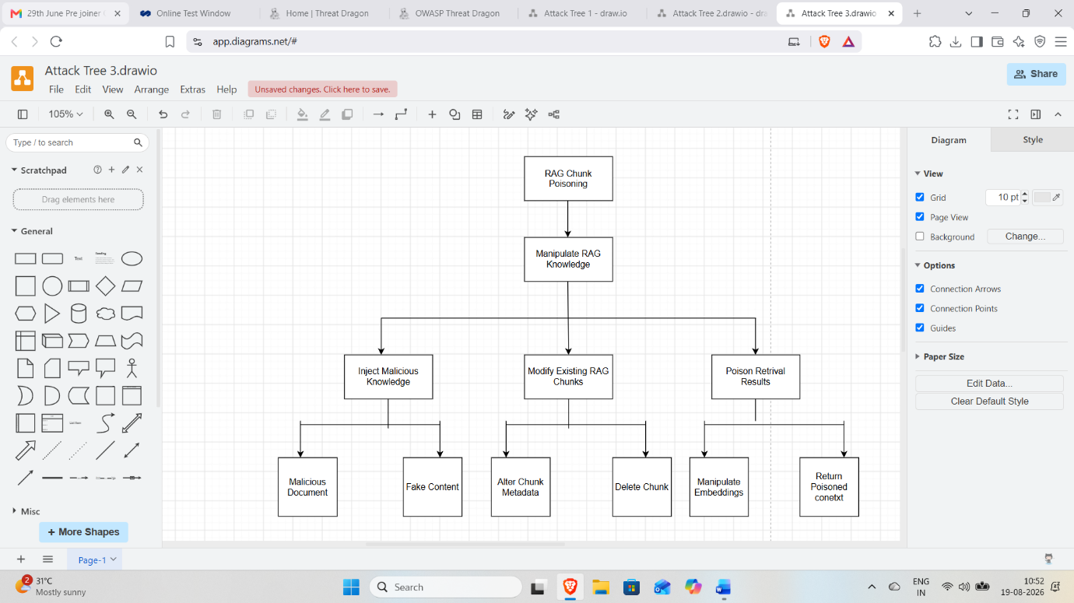
Attack Tree 3 showing the attack paths for RAG Chunk Poisoning, including malicious knowledge, modified chunks, and poisoned retrieval results.

6)STRIDE Risk Matrix
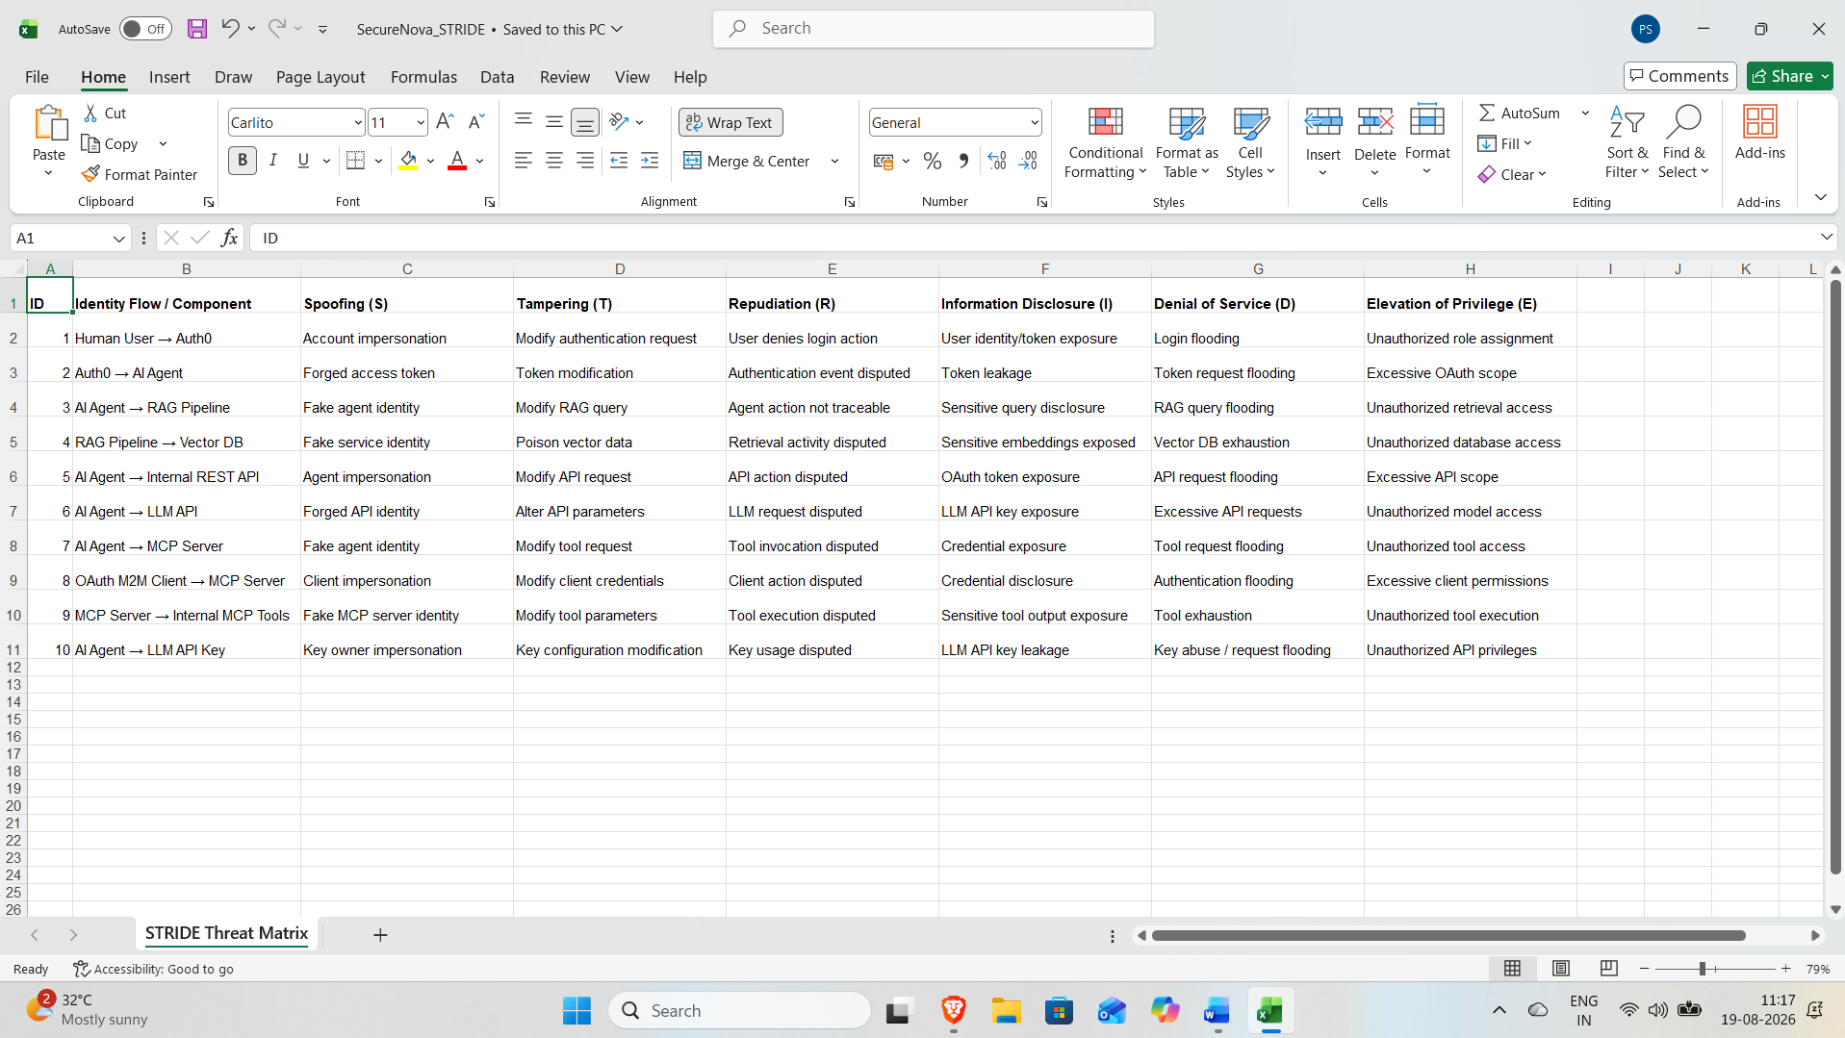
Excel STRIDE Threat Matrix containing all identity flows and the six STRIDE threat categories.

7)Risk Register
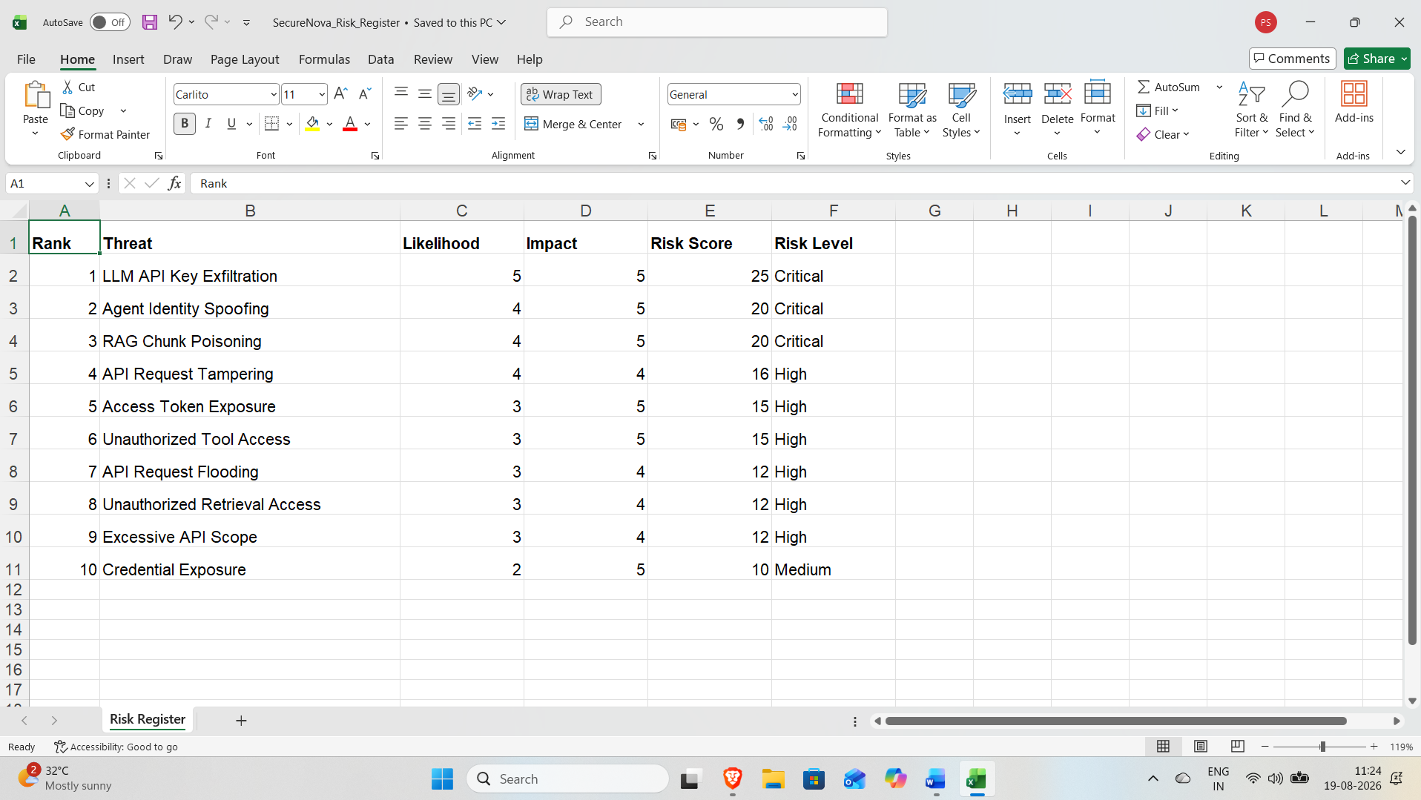
Risk Register spreadsheet showing identified threats scored and ranked by Risk Score.

8)MITRE ATLAS Mapping
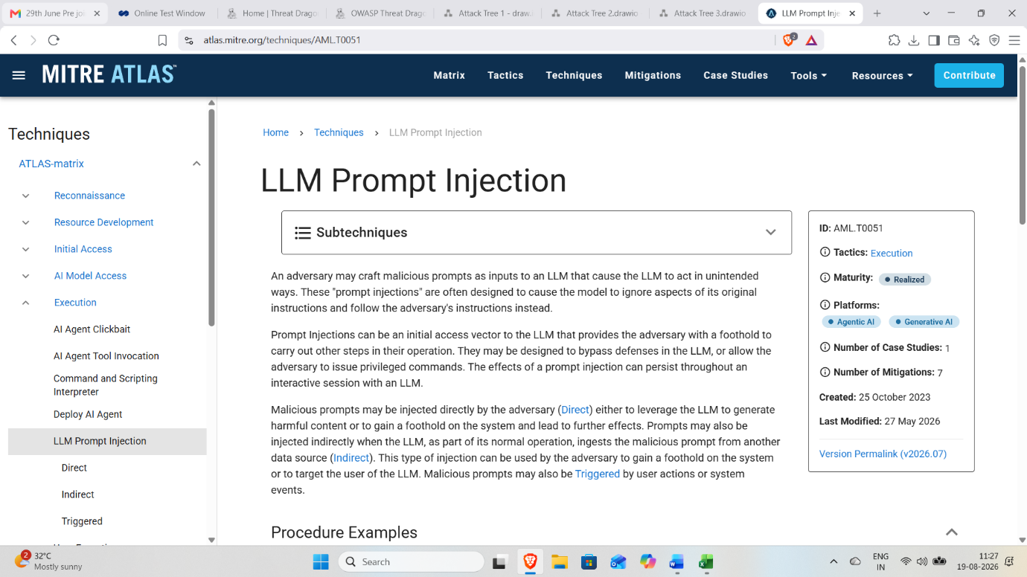
MITRE ATLAS LLM Prompt Injection technique (AML.T0051) related to malicious prompt manipulation of LLMs.

